PN 25/40 | STANDARDNA IZVEDBA  STANDARD DESIGN
KUĆIŠTE  BODY |  | GS-C25/ W.Nr. 1.0619  STEEL EN-JL 1040/1.4408
UNUTARNJI DIJELOVI  INNER PARTS |  | NEHRĐAJUĆI ČELIK  STAINLESS STEEL
NAZIVNI OTVOR  NOMINAL DIAMETER |  | DN 15-150
NAZIVNI TLAK (bar)  NOMINAL PRESSURE |  | PN 25/40
TEMPERATURA  TEMPERATURE RANGE |  | DO 450⁰C  TO 450⁰C
SPAJANJE  CONNECTION |  | PRIRUBNICA DIN 2501  FLANGES
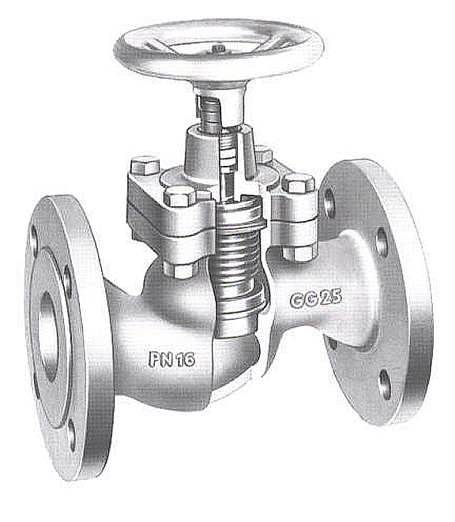

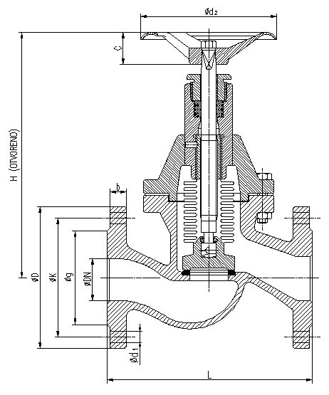

DN | L | H | øD | øK | ød₁ | n | masa  weight  kg
15 | 130 | 220 | 95 | 65 | 14 | 4 | 4
20 | 150 | 220 | 105 | 75 | 14 | 4 | 4
25 | 160 | 220 | 115 | 85 | 14 | 4 | 4,5
32 | 180 | 220 | 140 | 100 | 18 | 4 | 8,5
40 | 200 | 255 | 150 | 110 | 18 | 4 | 12
50 | 230 | 260 | 165 | 125 | 18 | 4 | 15
65 | 290 | 330 | 185 | 145 | 18 | 8 | 22
80 | 310 | 335 | 200 | 160 | 18 | 8 | 36
100 | 350 | 380 | 235 | 190 | 22 | 8 | 50
125 | 400 | 505 | 270 | 220 | 26 | 8 | 70
150 | 480 | 545 | 300 | 250 | 26 | 8 | 98

