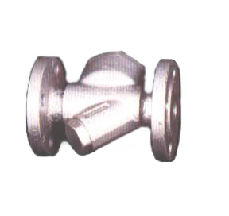
PN 6-40 | STANDARDNA IZVEDBA  STANDARD DESIGN
KUĆIŠTE  BODY |  | C22/ W.Nr. 1.0402  CARBON STEEL
UNUTARNJI DIJELOVI  INNER PARTS |  | NEHRĐAJUĆI ČELIK  STAINLESS STEEL
NAZIVNI OTVOR  NOMINAL DIAMETER |  | DN 10-25
NAZIVNI TLAK (bar)  NOMINAL PRESSURE |  | PN 6-40
TEMPERATURA  TEMPERATURE RANGE |  | DO 400⁰C  TO 400⁰C

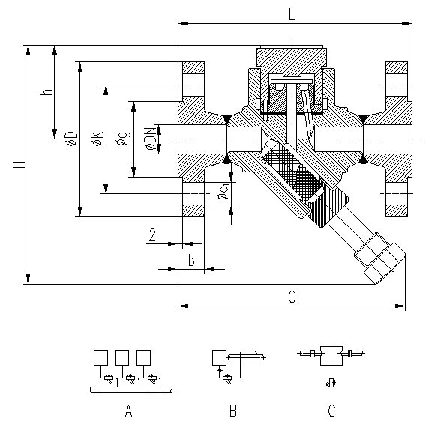

NAMJENA: VODA, PARA

CONTENS: WATER, STEAM

PN |  |  | 10 | DN  15 | 20 | 25
L | 6 |  | 130 | 150 | 150 | 160
L | 16/40 |  | 140 | 150 | 150 | 160
H | 6-40 |  | 122 | 162 | 172 | 180
øD | 6 |  | 75 | 80 | 90 | 100
øD | 16/40 |  | 90 | 95 | 105 | 115
ød₁ | 6 |  | 11 | 11 | 11 | 11
ød₁ | 16/40 |  | 14 | 14 | 14 | 14
C | 6 |  | 122 | 155 | 163 | 168
C | 16/40 |  | 126 | 155 | 163 | 168
h | 6-40 |  | 48 | 50 | 58 | 64
øK | 6 |  | 50 | 55 | 65 | 75
øK | 16/40 |  | 60 | 65 | 75 | 85
n | 6-40 |  | 4 | 4 | 4 | 4
Masa  weight  kg | 6 |  | 2,3 | 3,0 | 4,2 | 5,0
Masa  weight  kg | 16/40 |  | 2,7 | 3,3 | 4,4 | 5,2

