PN 16/40 | STANDARDNA IZVEDBA  STANDARD DESIGN
KUĆIŠTE  BODY | GS-C25/ W.Nr. 1.0619  CAST STEEL GP240GH
UNUTARNJI DIJELOVI  INNER PARTS | NEHRĐAJUĆI ČELIK  STAINLESS STEEL
NAZIVNI OTVOR  NOMINAL DIAMETER | DN 100-200 (PN 16)  DN 25-100 (PN 40)
NAZIVNI TLAK (bar)  NOMINAL PRESSURE | PN 16  PN 40
SPAJANJE  CONNECTION | PRIRUBNICA DIN 2501  FLANGES
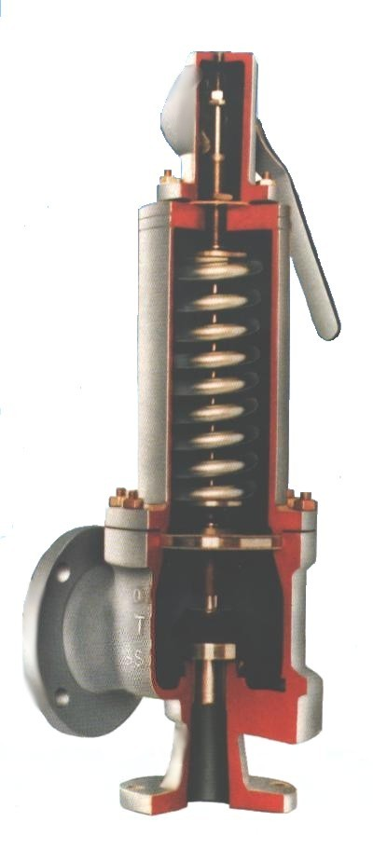

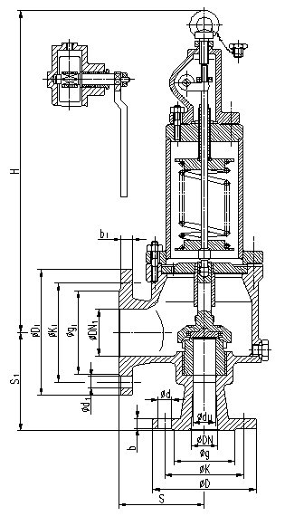

DN | øD | øK | ød | n | H | S | DN₁ | øD₁ | øK₁ | ød₁ | n₁ | S₁ | Masa  Weight  kg
25 | 115 | 85 | 14 | 4 | 417 | 105 | 40 | 150 | 110 | 18 | 4 | 115 | 15
32 | 140 | 100 | 18 | 4 | 428 | 110 | 50 | 165 | 125 | 18 | 4 | 125 | 19
40 | 150 | 110 | 18 | 4 | 473 | 120 | 65 | 185 | 145 | 18 | 8 | 135 | 26
50 | 165 | 125 | 18 | 4 | 610 | 140 | 80 | 200 | 160 | 18 | 8 | 150 | 35
65 | 185 | 145 | 18 | 8 | 629 | 140 | 100 | 220 | 180 | 18 | 8 | 160 | 47
80 | 200 | 160 | 18 | 8 | 707 | 160 | 125 | 250 | 210 | 18 | 8 | 175 | 70
100 | 235 | 190 | 22 | 8 | 756 | 180 | 150 | 285 | 240 | 22 | 8 | 200 | 101
125 | 250 | 210 | 18 | 8 | 826 | 200 | 200 | 340 | 295 | 22 | 12 | 200 | 138
150 | 285 | 240 | 22 | 8 | 1100 | 205 | 200 | 340 | 295 | 22 | 12 | 250 | 163
200 | 340 | 295 | 22 | 12 | 1200 | 280 | 300 | 445 | 400 | 22 | 12 | 320 | 192

