PN 25/40 | STANDARDNA IZVEDBA  STANDARD DESIGN
KUĆIŠTE  BODY | GS-C25/ W.Nr. 1.0619  CAST STEEL GP240GH
UNUTARNJI DIJELOVI  INNER PARTS | NEHRĐAJUĆI ČELIK  STAINLESS STEEL
NAZIVNI OTVOR  NOMINAL DIAMETER | DN 15-200
NAZIVNI TLAK (bar)  NOMINAL PRESSURE | PN 25/40
TEMPERATURA  TEMPERATURE RANGE | DO 400⁰C  TO 400⁰C
SPAJANJE  CONNECTION | PRIRUBNICA DIN 2501  FLANGES
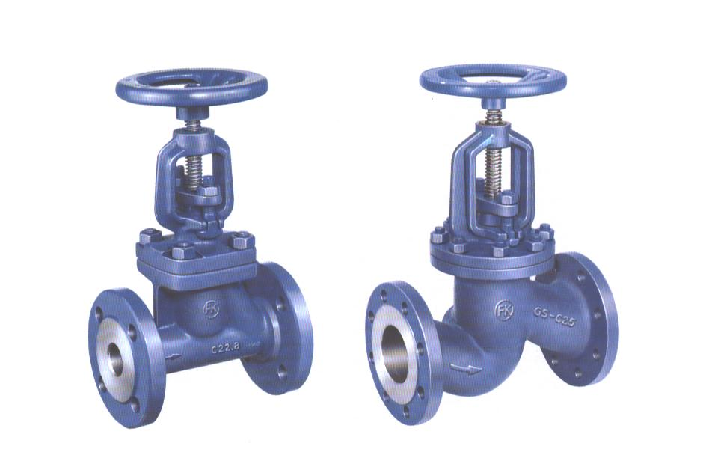

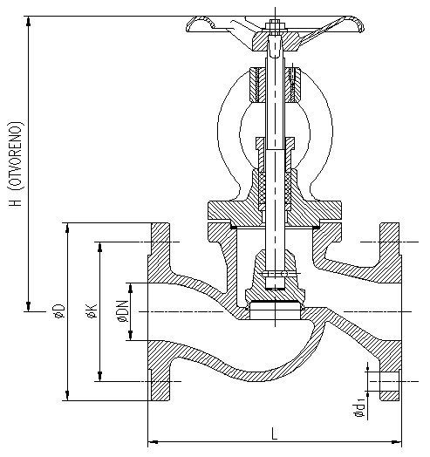
NAMJENA: VODA, PARA, ZRAK,
INERTNI PLINOVI.

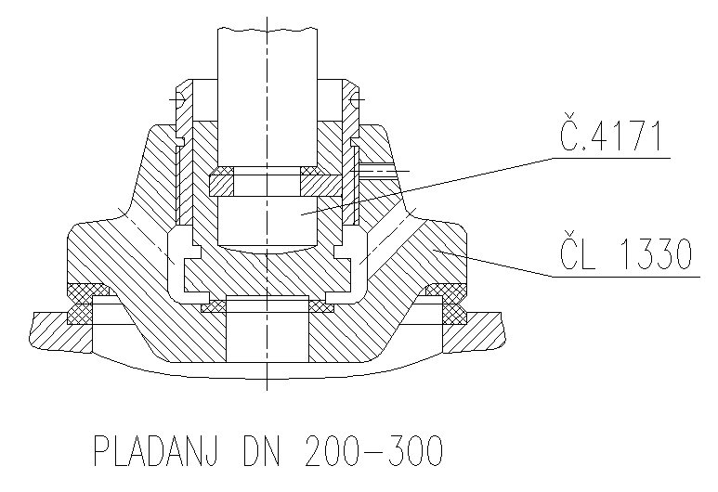

X15Cr13

GS-C25

PLADANJ DN 150-200

CONTENTS: WATER, STEAM, AIR,
INERT GASES.

DN | L | H | øD  25/40 | øK  25/40 | ød₁  25/40 | n | masa  weight  kg
15 | 130 | 197 | 95 | 65 | 14 | 4 | 4,3
20 | 150 | 217 | 105 | 75 | 14 | 4 | 6,1
25 | 160 | 225 | 115 | 85 | 14 | 4 | 7
32 | 180 | 228 | 140 | 100 | 18 | 4 | 11
40 | 200 | 257 | 150 | 110 | 18 | 4 | 14,6
50 | 230 | 306 | 165 | 125 | 18 | 4 | 14,8
65 | 290 | 360 | 185 | 145 | 18 | 8 | 27
80 | 310 | 398 | 200 | 160 | 18 | 8 | 36
100 | 350 | 484 | 235 | 190 | 22 | 8 | 51
125 | 400 | 536 | 270 | 220 | 26 | 8 | 78
150 | 480 | 574 | 300 | 250 | 26 | 8 | 106
200 | 600 | 685 | 360/375 | 3107320 | 26/30 | 12 | 165/182

