PN 25/40 | STANDARDNA IZVEDBA  STANDARD DESIGN
KUĆIŠTE  BODY |  | GS-C25/ W.Nr. 1.0619  CAST STEEL GP240GH
UNUTARNJI DIJELOVI  INNER PARTS |  | NEHRĐAJUĆI ČELIK  STAINLESS STEEL
NAZIVNI OTVOR  NOMINAL DIAMETER |  | DN 15-200
NAZIVNI TLAK (bar)  NOMINAL PRESSURE |  | PN 25/40
TEMPERATURA  TEMPERATURE RANGE |  | DO 400⁰C  TO 400⁰C
SPAJANJE  CONNECTION |  | PRIRUBNICA DIN 2501  FLANGES

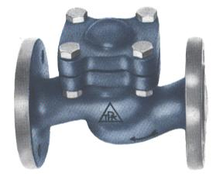

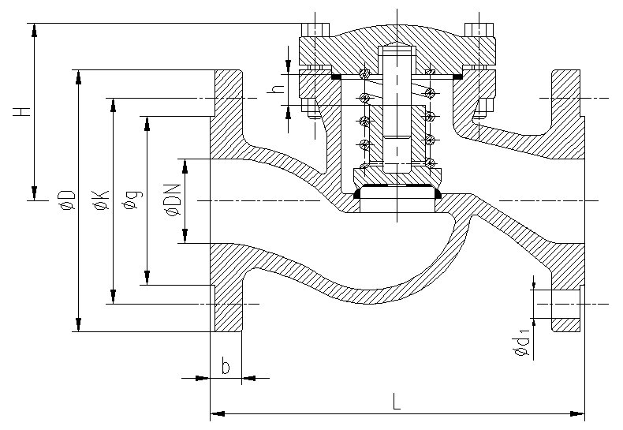

NAMJENA: VODA, PARA, ZRAK, INERTNI PLINOVI.

CONTENTS: WATER, STEAM, AIR, INERT GASES.

DN | L  25/40 | H  25/40 | øD  25/40 | øK  25/40 | ød₁  25/40 | n | Masa kg  weight  25/40
15 | 130 | 76 | 95 | 65 | 14 | 4 | 3,8
20 | 150 | 82 | 105 | 75 | 14 | 4 | 4,5
25 | 160 | 85 | 115 | 85 | 14 | 4 | 5,9
32 | 180 | 100 | 140 | 100 | 18 | 4 | 7,5
40 | 200 | 120 | 150 | 110 | 18 | 4 | 11,5
50 | 230 | 115 | 165 | 125 | 18 | 4 | 13,5
65 | 290 | 135 | 185 | 145 | 18 | 8 | 21,4
80 | 310 | 149 | 200 | 160 | 18 | 8 | 31
100 | 350 | 180 | 235 | 190 | 22 | 8 | 42,5
125 | 400 | 210 | 270 | 220 | 26 | 8 | 60
150 | 480 | 227 | 300 | 250 | 26 | 8 | 80
200 | 600 | 273 | 360/375 | 310/320 | 26/30 | 12 | 198

