PN 16 | STANDARDNA IZVEDBA  STANDARD DESIGN  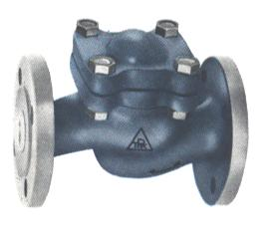
KUĆIŠTE  BODY |  | GG-25/ W.Nr. 0.6025  CAST IRON EN-JL 1040
UNUTARNJI DIJELOVI  INNER PARTS |  | NEHRĐAJUĆI ČELIK  STAINLESS STEEL
NAZIVNI OTVOR  NOMINAL DIAMETER |  | DN 15-200
NAZIVNI TLAK (bar)  NOMINAL PRESSURE |  | PN 16
TEMPERATURA  TEMPERATURE RANGE |  | DO 300⁰C  TO 300⁰C
SPAJANJE  CONNECTION |  | PRIRUBNICA DIN 2501  FLANGES
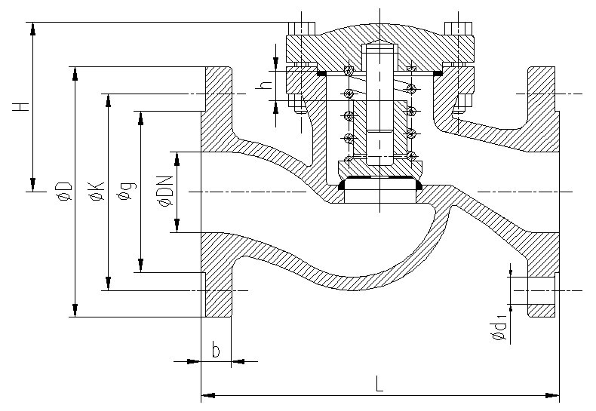

NAMJENA: VODA, PARA, ZRAK,
INERTNI PLINOVI.

CONTENTS: WATER, STEAM, AIR,
INERT GASES.

DN | L | H | øD | øK | ød₁ | n | masa  weight  kg
15 | 130 | 65 | 95 | 65 | 14 | 4 | 3
20 | 150 | 65 | 105 | 75 | 14 | 4 | 3,5
25 | 160 | 77 | 115 | 85 | 14 | 4 | 4,4
32 | 180 | 77 | 140 | 100 | 18 | 4 | 6,2
40 | 200 | 100 | 150 | 110 | 18 | 4 | 8
50 | 230 | 100 | 165 | 125 | 18 | 4 | 10,5
65 | 290 | 117 | 185 | 145 | 18 | 4 | 16
80 | 310 | 145 | 200 | 160 | 18 | 8 | 24
100 | 350 | 166 | 220 | 180 | 18 | 8 | 29
125 | 400 | 185 | 250 | 210 | 18 | 8 | 46
150 | 480 | 203 | 285 | 240 | 22 | 8 | 65
200 | 600 | 280 | 340 | 295 | 22 | 12 | 122

ø

